**OpenOCD for Ozzy & Tigershark**

Contents

**I.** **OCD for Ozzy** 1

**1.** **Download package** 2

**2.** **Binary file installation procedure** 2

**3.** **OPENOCD Launch and Usage** 2

a. Open OCD Server Launch 2

b. Open OCD Client Launch 2

c. Command (OCM run ) 2

**II.** **OCD for Tigershark** 4

**1.** **Download package** 4

**2.** **Binary file installation procedure** 4

**3.** **OPENOCD Launch and Usage** 4

a. Open OCD Server Launch 4

b. Open OCD Client Launch 4

c. Command (OCM run) 5

1. **OCD for Ozzy**
2. **Download package**

$ mkdir -p /home/hcmf8ddwm1/openocd/ozzy

$ cd /home/hcmf8ddwm1/openocd/ozzy

Get source from branch: //refPlatforms/storm_dev_boards/ozzy/tools/ocd/

1. **Binary file installation procedure**

For 64bit ubuntu system (please confirm with `uname -i` command)

$ cd /home/hcmf8ddwm1/openocd/ozzy/ocd/ozzy_onboard

$ tar xvzf openocd-storm-ozzy-x86_64-bin.tgz

1. **OPENOCD Launch and Usage**

$ export LD_LIBRARY_PATH=${LD_LIBRARY_PATH}:$PWD/openocd-storm-ozzy-x86_64-bin/lib

* 1. Open OCD Server Launch

$ sudo ./openocd-storm-ozzy-x86_64-bin/bin/openocd -f ozzy.cfg

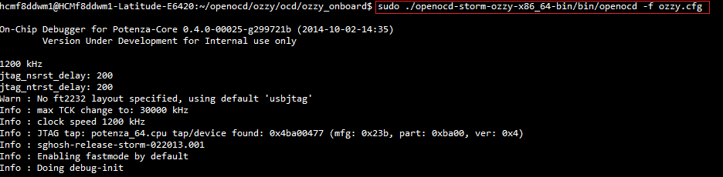

* 1. Open OCD Client Launch

$ telnet localhost 4444

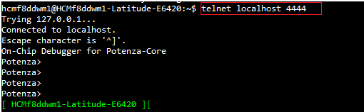

* 1. Command (OCM run )
* On Potenza

Potenza> poll on; reset; halt; halt

Potenza> script /tftpboot/ocd/ozzy/mustang_resetall.tcl

Potenza> load_image /tftpboot/ocd/ozzy/u-boot-ocm.bin 0x1d000000

Potenza> script /tftpboot/ocd/ozzy/mustang_start0.tcl

Potenza> load_image /tftpboot/ocd/ozzy/ozzy_media.img 0x4001000000

Wait load image done:

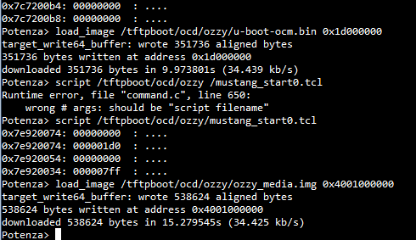

* On console

Ozzy# setenv filesize 0x83800

Ozzy# sf probe 0

Ozzy# sf erase 0x0 0x83800

Ozzy# sf write ${media_addr_r} 0x0 0x83800

Ozzy# reset

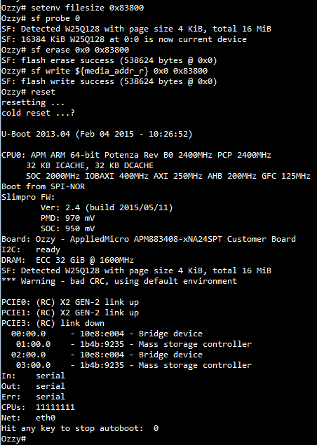

1. **OCD for Tigershark**

1. **Download package**

$ mkdir -p mkdir -p /home/hcmf8ddwm1/openocd/shadowcat

$ cd /home/hcmf8ddwm1/openocd/shadowcat

Get source from branch: //processor/shadowcat/tools/ocd/

1. **Binary file installation procedure**

For 64bit ubuntu system (please confirm with `uname -i` command)

$ cd /home/hcmf8ddwm1/openocd/shadowcat/ocd

$ tar xvzf ./apm_xgene_ocd_2.02.00.tgz

$ cd apm_xgene_oc_2.02.00

$ tar xvf ./Shadowcat_OCD_release.tgz

$ cd Shadowcat_OCD_release

$ tar xvf ./openocd-storm-x86_64-bin.tgz

1. **OPENOCD Launch and Usage**

$ export LD_LIBRARY_PATH=${LD_LIBRARY_PATH}:${PWD}/usr/local/lib

# Edit config file shadowcat_a0.cfg

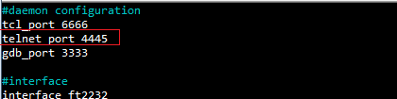

1. Open OCD Server Launch

$ ./usr/local/bin/openocd -f shadowcat_a0.cfg

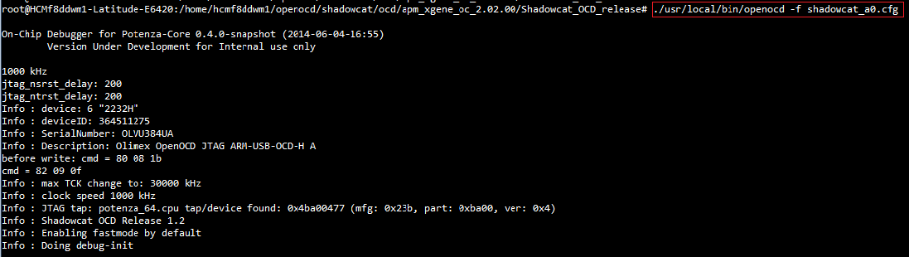

1. Open OCD Client Launch

$ telnet localhost 4445

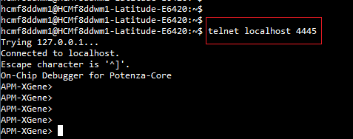

1. Command (OCM run)

APM-XGene> poll on; reset; halt; halt

APM-XGene> script /tftpboot/ocd/tigershark/resetall.tcl

APM-XGene> load_image /tftpboot/ocd/tigershark/uboot-tigershark-ocm.bin 0x1d000000

APM-XGene> script /tftpboot/ocd/tigershark/start0.tcl

APM-XGene> load_image /tftpboot/ocd/tigershark/uboot_tigershark_media.img 0x4001000000

Wait load image done:

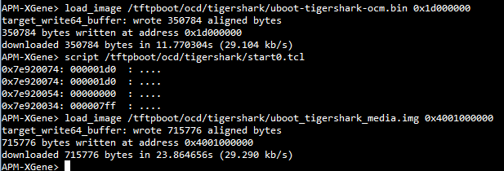

* On console

Tigershark# setenv filesize 0xaec00

Tigershark# sf probe 0

Tigershark# sf erase 0x0 0xaec00

Tigershark# sf write ${media_addr_r} 0x0 0xaec00

Tigershark# reset

Note:

